KOSGEB Entrepreneur Support Program from Idea to Market

KOSGEB Entrepreneur Support Program from Idea to Market

Dr. UÄŸur CORUH

## Download Files

* [DOC](girisimcilik-sunum.doc.pdf)
* [SLIDE](girisimcilik-sunum.slide.pdf)
* [PPTX](girisimcilik-sunum.slide.pptx)



# KOSGEB Entrepreneur Support Program from Idea to Market

### **What is a project?** â†’ **Why should you get support?** â†’ **How do you start?** â†’ **Develop, Grow, Commercialize!**

Learn the steps to grow your business with a project!

){height=100](assets/rteu_logo.jpg)}

Dr. UÄŸur CORUH

* Coruh Arge ve Teknoloji, General Manager
* Recep Tayyip ErdoÄŸan Uni. Department of Computer Engineering, Dr. Lecturer



## 1. What is a Project and Why is it Important?

### Question: What is a project?

* **Answer**: A project is a planned effort to achieve a specific goal. Projects are carried out to grow your business, offer new products, or increase efficiency.
  + Purpose
  + Goal
  + Plan
  + Action
  + Result

### Project Elements

* **Project Purpose**  
  The general purpose of the project is to solve the targeted problems or seize opportunities.
* **Project Objectives**  
  Specific and measurable outcomes of the project.
* **Project Innovation Value**  
  What makes your project innovative and unique compared to other projects?
* **Project Duration**  
  Estimated start and end dates of the project provide information about the duration.
* **Project Team**  
  Roles and areas of expertise of those contributing to the project.
* **Project Budget**  
  The cost and budget items of the project.
* **Project Methods and Application**  
  What methods and strategies will the project be carried out with?
* **Project Outputs**  
  Outputs and results to be obtained when the project is completed.

### Example Project Plan (Gantt Chart)

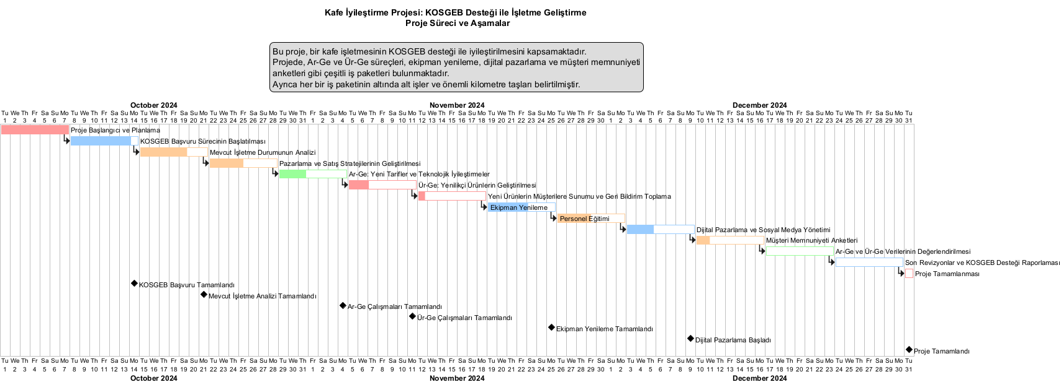

### Technology Readiness Levels

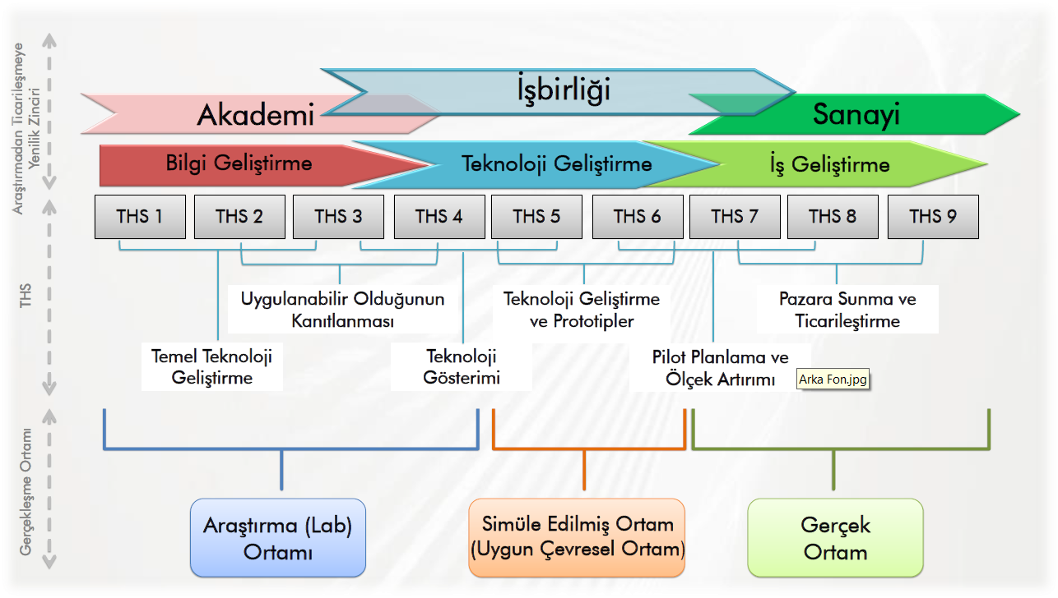



### Question: What is the purpose of doing a project?

* **Answer**: Projects create new opportunities to grow your business. You can finance your projects with support such as KOSGEB and help your business grow.



### Example:

* **A cafe owner**: “I want to grow my cafe but I don’t know how to start.”
  + Solution: By doing a project, you can buy new equipment and finance it with KOSGEB support.



## Projects That Can Be Developed for Tradesmen, Artisans, and Manufacturers in Rize with KOSGEB Support



## 1. Digitalization and E-Commerce Projects

* **Digitalization Projects for Tradesmen:** Projects can be developed to help tradesmen establish a presence on digital platforms and enable them to sell online. KOSGEB can provide financing to businesses for digital transformation processes.
  + E-commerce site setup and integration
  + Social media marketing and digital advertising
  + Mobile application development
* **Digitalization Projects for Manufacturers:** Projects can be developed to support manufacturers’ digital transformation in production processes. Projects may focus on smart manufacturing, IoT (Internet of Things)-based automation, data analytics, and cloud computing integrations.



## 2. Production Capacity Increase Projects

* **Establishing a New Production Line and Modernization:** Projects can be developed to purchase new machines and equipment to increase manufacturers’ production capacity, modernize production lines, and optimize production processes. These projects can be realized with KOSGEB’s machinery-equipment support.
  + Increasing production capacity with small-scale machines for tradesmen and small manufacturers
  + Automation systems and Industry 4.0 integration for large-scale manufacturers



## 3. R&D and Product Development (R&D/PD) Projects

* **New Product Development (PD) Projects:** Projects can be developed for new product development for tradesmen and small businesses with KOSGEB’s PD support. These projects include prototyping, testing, and bringing new products to market.
* **Research and Development (R&D) Projects:** Projects can be developed by manufacturers on new production technologies, materials, and production processes. With the support KOSGEB provides for R&D projects, innovative products and processes can be developed and commercialized.
  + Innovative product development projects, especially in sectors such as furniture, textiles, and automotive sub-industry
  + Environmentally friendly production technologies and sustainability projects



## 4. Productivity Improvement Projects

* **Productivity Enhancing Techniques in Businesses:** Projects can be developed for small tradesmen and manufacturers to reduce operating costs and increase productivity. KOSGEB provides support for productivity improvement.
  + Energy efficiency projects
  + Optimization of business processes and inventory management projects
  + Integration of quality management systems



## 5. Marketing and Branding Projects

* **Branding Projects for Local Tradesmen and Small Businesses:** With KOSGEB’s marketing support, the branding processes of tradesmen and small businesses can be accelerated. Projects can be prepared on corporate identity development, brand promotion, and online and offline advertising strategies.
  + Packaging and branding of local products
  + Target audience analysis and marketing strategy development
* **Export-Oriented Marketing Projects:** Export-oriented marketing projects can be developed for manufacturers and large producers aiming to expand internationally. KOSGEB provides financial support for export projects.
  + Participation in international fairs
  + Preparation of export documents and market research
  + Introduction of products to international markets



## 6. Social Entrepreneurship and Cooperative Projects

* **Strengthening Tradesmen’s Cooperatives:** Projects can be developed to establish cooperatives for tradesmen, allowing small tradesmen to combine their strengths and compete more effectively in the market with KOSGEB support.
  + Joint purchasing and production projects through cooperatives
  + Digitization of cooperatives and integration into e-commerce platforms
* **Social Responsibility Projects:** Tradesmen and small businesses can contribute to social development through social entrepreneurship projects. KOSGEB also provides support for social responsibility projects.



## 7. Financial Management and Stability Projects

* **Financial Management and Planning Training Projects:** Financial management training and budget planning projects can be developed for tradesmen and artisans. These projects can be supported through KOSGEB’s entrepreneurship training.
  + Cash flow management training for tradesmen
  + Financial stability and sustainability training for SMEs



## 8. Employment and Personnel Training Projects

* **Vocational Training and Skilled Workforce Development:** KOSGEB provides support for training projects aimed at improving the workforce for tradesmen and manufacturers. Personnel training, professional development programs, and certification projects can be developed.
  + Apprenticeship and master trainer programs
  + Professional competency certification projects
* **Inclusive Employment Projects:** Social responsibility projects aimed at integrating women and young people into the workforce can be developed. KOSGEB supports such projects.



## 9. Sustainability and Environmentally Friendly Projects

* **Waste Management and Recycling Projects:** Projects can be developed on waste management, recycling, and environmentally friendly production techniques with the support KOSGEB provides for eco-friendly projects.
  + Establishment of waste management systems for tradesmen and artisans
  + Use of environmentally friendly materials in production facilities
* **Carbon Footprint Reduction Projects:** Projects can be developed to improve energy efficiency and reduce carbon emissions for manufacturers. The use of renewable energy sources can be encouraged.



## 10. Supply Chain and Logistics Projects

* **Strengthening the Supply Chain:** Projects can be prepared, particularly for manufacturers, on digital transformation in supply chain management, improving logistics networks, and strengthening distribution channels.
  + Logistics automation systems
  + Creating digital supply chain platforms
* **Integration of local products into the national market:** Projects can be developed to create national distribution networks that allow tradesmen and small producers to reach wider audiences.



## Business Plan Example



## **Step 1: What is the KOSGEB Business Plan and Why is it Necessary?**

* **What is it?**: The business plan required for KOSGEB applications is a comprehensive document that shows your business goals and how you will achieve them.
* **Why is it Necessary?**: You must have a business plan to demonstrate your businessâ€™s financial soundness and present your plans to investors and KOSGEB.

#### **Example:**

* “Y GÄ±da Ltd. aims to become a snack brand distributing nationwide in Turkey by applying to KOSGEB support programs in 2024.”



## **Step 2: Executive Summary**

* **What is it?**: The top-level summary of your business plan briefly describes your business and objectives.
* **What Should it Include?**: The companyâ€™s core values, the product/service you offer, your target audience, and market opportunities.

#### **Example:**

* “X Electronics is a company that produces electronic devices with domestic production in Turkey. We aim to double our production capacity in 2024 with KOSGEB support.”



## **Step 3: Target Audience and Market Analysis**

* **What is it?**: Identify who your product/service is for and your position in the market.
* **What Should it Include?**: Who are your customers, how big is the market, and who are your competitors? KOSGEB will want to see details in this area.

#### **Example:**

* “Our target audience is technology enthusiasts aged 18-40. There are strong competitors like Z Electronics in the Turkish market, but we plan to differentiate by leveraging our domestic production advantage.”



## **Step 4: Product or Service Description**

* **What is it?**: The description of the product or service you are offering is crucial in the KOSGEB business plan.
* **What Should it Include?**: How your product/service solves customer problems and how it differs from competitors.

#### **Example:**

* “Our product is durable electronic devices produced entirely with local materials. It is more affordable and long-lasting compared to our competitors.”



## **Step 5: KOSGEB-Supported Marketing Strategy**

* **What is it?**: Detail your market entry strategy and how your sales channels will operate.
* **What Should it Include?**: Digital marketing, social media, advertising campaigns, sales channels, and how KOSGEB will be utilized.

#### **Example:**

* “We will run advertising campaigns on Instagram and Facebook to promote our product. We will also benefit from KOSGEB’s digital marketing support.”



## **Step 6: Production and Logistics Plan**

* **What is it?**: Another critical aspect that KOSGEB will pay attention to is your business’s production and distribution processes.
* **What Should it Include?**: Production processes, inventory management, logistics, and supply chain planning.

#### **Example:**

* “Production will take place in our factory in Izmir, and the products will be distributed across Turkey via contracted cargo companies. We will expand our machine park using KOSGEBâ€™s equipment support.”



## **Step 7: Financial Plan and KOSGEB Support**

* **What is it?**: This part of your business plan should detail how you will use KOSGEBâ€™s support and your financial projections.
* **What Should it Include?**: Revenue projections, costs, KOSGEB support, capital requirements.

#### **Example:**

* “We plan an investment of 500,000 TL for 2024. With the 100,000 TL grant support from KOSGEB, we aim to expand our production facility.”



## **Step 8: Risks and Solution Strategies**

* **What is it?**: Every business faces potential risks, and KOSGEB wants to know how you will mitigate these risks.
* **What Should it Include?**: Market, financial, and operational risks, along with proposed solutions.

#### **Example:**

* “An increase in raw material prices may raise production costs. We will negotiate with alternative suppliers to minimize cost increases.”



## **Step 9: Business Timeline for KOSGEB (with Gantt Chart)**

* **What is it?**: You must organize every step of your business chronologically.
* **What Should it Include?**: Start and end dates for each step, important documents to be submitted to KOSGEB, and milestones.

#### **Example:**

* “Production will start in March 2024, and the first products will be available for sale in June 2024. KOSGEB reports will be submitted regularly every 3 months.”



## **Step 10: Short and Long-Term Goals**

* **What is it?**: You need to clearly and strategically communicate your business goals to KOSGEB.
* **What Should it Include?**: Short-term goals (first-year sales targets), long-term goals (expansion and growth plans).

#### **Example:**

* “In the short term, we aim to reach 5,000 customers nationwide in Turkey, and in the long term, expand into the European market. We will strengthen our technology infrastructure with KOSGEB support.”



### **Conclusion:**

* Submitting a business plan to KOSGEB should be backed by a detailed and strategic roadmap. By following this business plan guide, you can make the best use of KOSGEBâ€™s support and grow your business.



## 2. How to Develop Your Business? (From Idea to Project)

### Question: How can I improve my business?

* **Answer**: Analyze your current business.
  + You can increase production,
  + offer new products, or
  + advertise to attract more customers.



### Question: How can I turn my ideas into projects?

* **Answer**: Identify your needs and think of solutions. For example, you can invest in digital marketing to attract more customers.



### Example:

* **A grocery store owner**: “I want to reach more customers.”
  + Solution: You can create a project, start online sales, and set up a website with KOSGEB support.



## 3. KOSGEB Support: Why Should You Apply?

### Question: What is KOSGEB support?

* **Answer**: KOSGEB is an institution that provides financial support to small and medium-sized businesses. You can apply for projects to get the money you need to develop your business.



### Question: Why should I get support from KOSGEB?

* **Answer**: You can get financial support to bring your projects to life faster and with less risk. This support can be used to buy new machinery, expand your business, or for marketing.



### Example:

* **A tailor**: “I want to take more orders but I can’t buy new machines.”
  + Solution: You can apply to KOSGEB and buy new sewing machines with the machinery-equipment support.



## 4. Preparing a Business Plan: Plan Your Project

### Question: What is a business plan?

* **Answer**: A business plan is a document that explains what your business will do in the future, how it will make money, and what it needs. A business plan is required for KOSGEB support.



### Question: How do I prepare a business plan?

* **Answer**: Write down what your business will do, what product or service it will offer, who it will target, and how you will carry out the project.

### Business Model Canvas

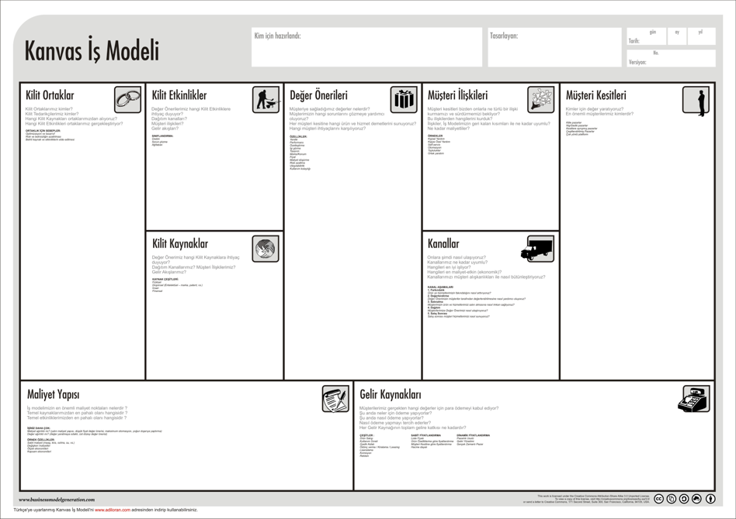



### Example:

* **A bakery owner**: “I want to buy new baking machines but don’t know where to start.”
  + Solution: In your business plan, explain the machines you need, why you need this investment, and how these machines will benefit your business.



## 5. Project Application Process: Step by Step

### Question: How can I apply to KOSGEB?

* **Answer**: To apply to KOSGEB, you first need to attend entrepreneurship training, then prepare your business plan and fill out the application forms.



### Application Steps:

1. Complete the entrepreneurship training.
2. Prepare your business plan.
3. Apply to KOSGEB.



### Example:

* **A butcher**: “What do I need to do to grow my business?”
  + Solution: After getting your entrepreneurship certificate and preparing your business plan, you can apply to KOSGEB for support.



## 6. R&D and Product Development (R&D/PD): Making Innovations

### Question: What is R&D?

* **Answer**: Research and Development (R&D) refers to the activities undertaken to develop new products or improve existing ones. KOSGEB supports R&D projects.



### Question: What is Product Development (PD)?

* **Answer**: Product Development (PD) focuses on improving existing products to increase your competitive edge in the market.



### Example:

* **A candy maker**: “I want to develop a new type of candy.”
  + Solution: You can test and develop your new product with R&D support.



## 7. Path to Market: Launching Your Product

### Question: How do I bring my product to market?

* **Answer**: You need to determine pricing, advertising, and sales channels to bring your product to market. KOSGEB also provides marketing support.



### Example:

* **A home goods store**: “How can I reach more people with my products?”
  + Solution: You can enter online sales platforms and use digital advertising with KOSGEB marketing support.



## 8. Advanced Information and In-Depth Explanations

### 8.1 Evaluate Your Business with a SWOT Analysis

#### Question: What are your business’s strengths and weaknesses?

* **Answer**: You may have high customer satisfaction, but your digital infrastructure might be lacking.



#### SWOT Table:

* **Strengths**: High-quality products, customer loyalty.
* **Weaknesses**: Lack of digital infrastructure, insufficient marketing.
* **Opportunities**: Transition to online sales, new customer base.
* **Threats**: Increasing number of competitors, changing market dynamics.



## 8.2 Shape Your Project with the Business Model Canvas

#### Question: What value do you offer to customers? (Value Proposition)

* **Answer**: You can offer value to customers through high quality, affordable prices, and fast delivery.



#### Example:

* **An e-commerce company**: “We offer fast delivery and reliable shopping.”
  + Solution: Improve your logistics infrastructure with KOSGEB support.



## 8.3 Develop Innovative Products and Technologies with R&D

#### What is the R&D Process?

* **Research**: Investigate customer demands and technological innovations.
* **Prototype Development**: Test and develop new product ideas.
* **Implementation**: Launch your products to the market and optimize production processes.



#### KOSGEB R&D Support

* **Machinery and Equipment Support**: Support for equipment used in R&D projects.
* **Personnel Support**: Hiring expert personnel for R&D projects.



## 8.4 Improve Your Existing Products with Product Development (PD)

#### What is Product Development (PD)?

* **Answer**: PD is the process of improving existing products or services to make them more competitive.



#### PD Stages

* **Customer Feedback**: Take customer feedback into account to improve your products.
* **Improvement and Redesign**: Make improvements that increase product quality.



## 8.5 Integrate SWOT and the Business Model Canvas

#### Question: How do you use SWOT and the Business Model Canvas?

* **Answer**: Analyze your business’s strengths and weaknesses with SWOT and create your business plan within a strategic framework using the Business Model Canvas.



#### Example:

* **A food manufacturer**: “How can I control costs while increasing production capacity?”
  + Solution: Use SWOT analysis to identify costs and the Business Model Canvas to plan new revenue streams.

## 9. Thank You!

#### Question and Answer Section

* Ask your questions about projects.
* For more information: [kosgeb.gov.tr](https://www.kosgeb.gov.tr)
* Check out the Frequently Asked Questions page
  + https://www.kosgeb.gov.tr/Web/Genel/SSS.aspx?KatID=2
* Entrepreneur Support Program
  + https://www.kosgeb.gov.tr/site/tr/genel/destekdetay/1231/girisimci-destek-programi
* You can get consultancy and support from chambers of commerce.

# From Idea to Market with KOSGEB Entrepreneur Support Program



Dr. UÄŸur CORUH

* General Manager of Coruh Arge ve Teknoloji
  + (ugur.coruh@coruh.com.tr)
* Assistant Professor, Computer Engineering Department, Recep Tayyip ErdoÄŸan University
  + (ugur.coruh@erdogan.edu.tr)